Splash Screen

Workshop #02

Flutter Developer Bootcamp

# **Purpose**

This workshop demonstrates how to Create A Splash Screen.

# **Problem**

In the workshop, make a splash screen. It should last 3 seconds and have a blue background. The splash should show a Flutter picture or icon and some Text.

# **How to Solve**

1. Checkout the workshop from Git Repo:

git clone -b <user-branch> <repo-URL>

2. Open the root folder inside VS Code

3. To build the app click the run option in the main method { }

4. Create a splash screen with flutter icon or image

5. The background colour must be blue.

# **You Will Achieve**

At the completion of the workshop, you will study how to set up a splash screen with a timer.

# **Screenshots**

## **Before implementation (without Splash Screen)**

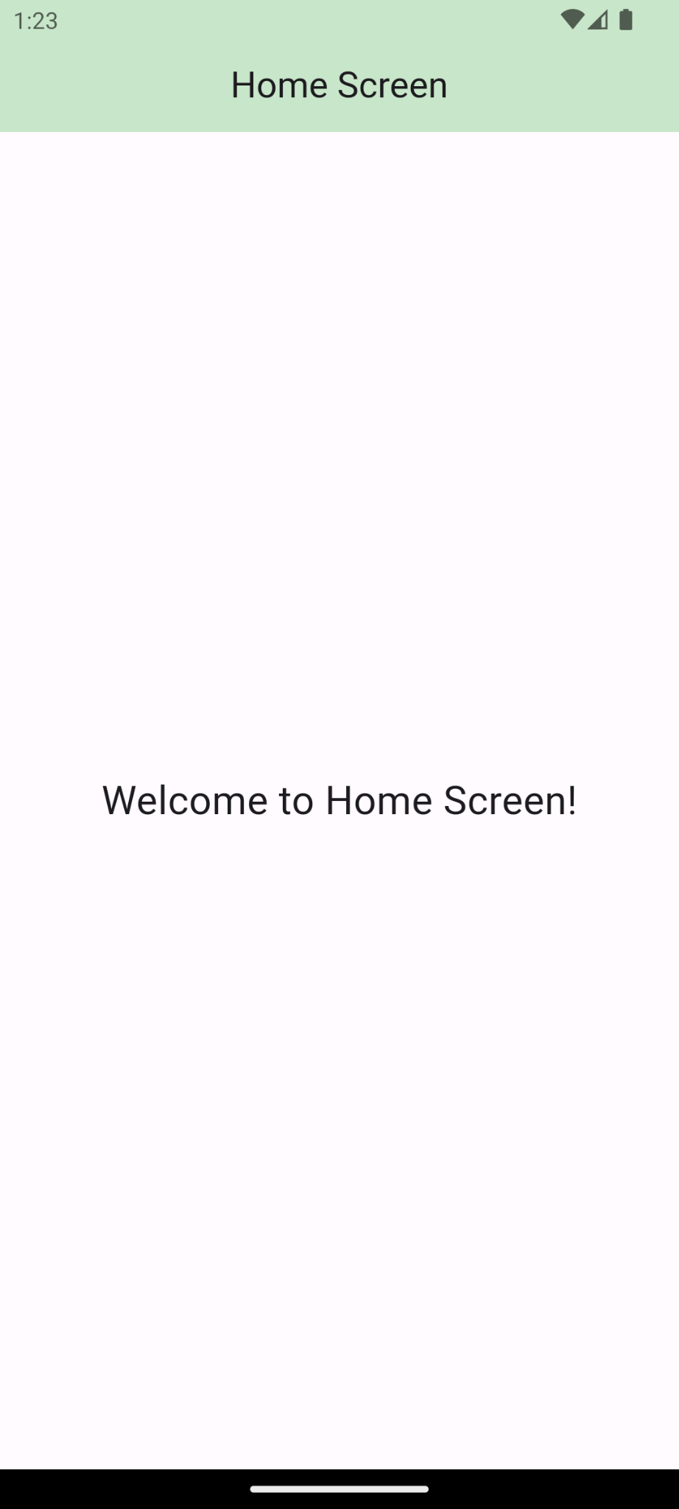

## **After implementation (With Splash Screen)**

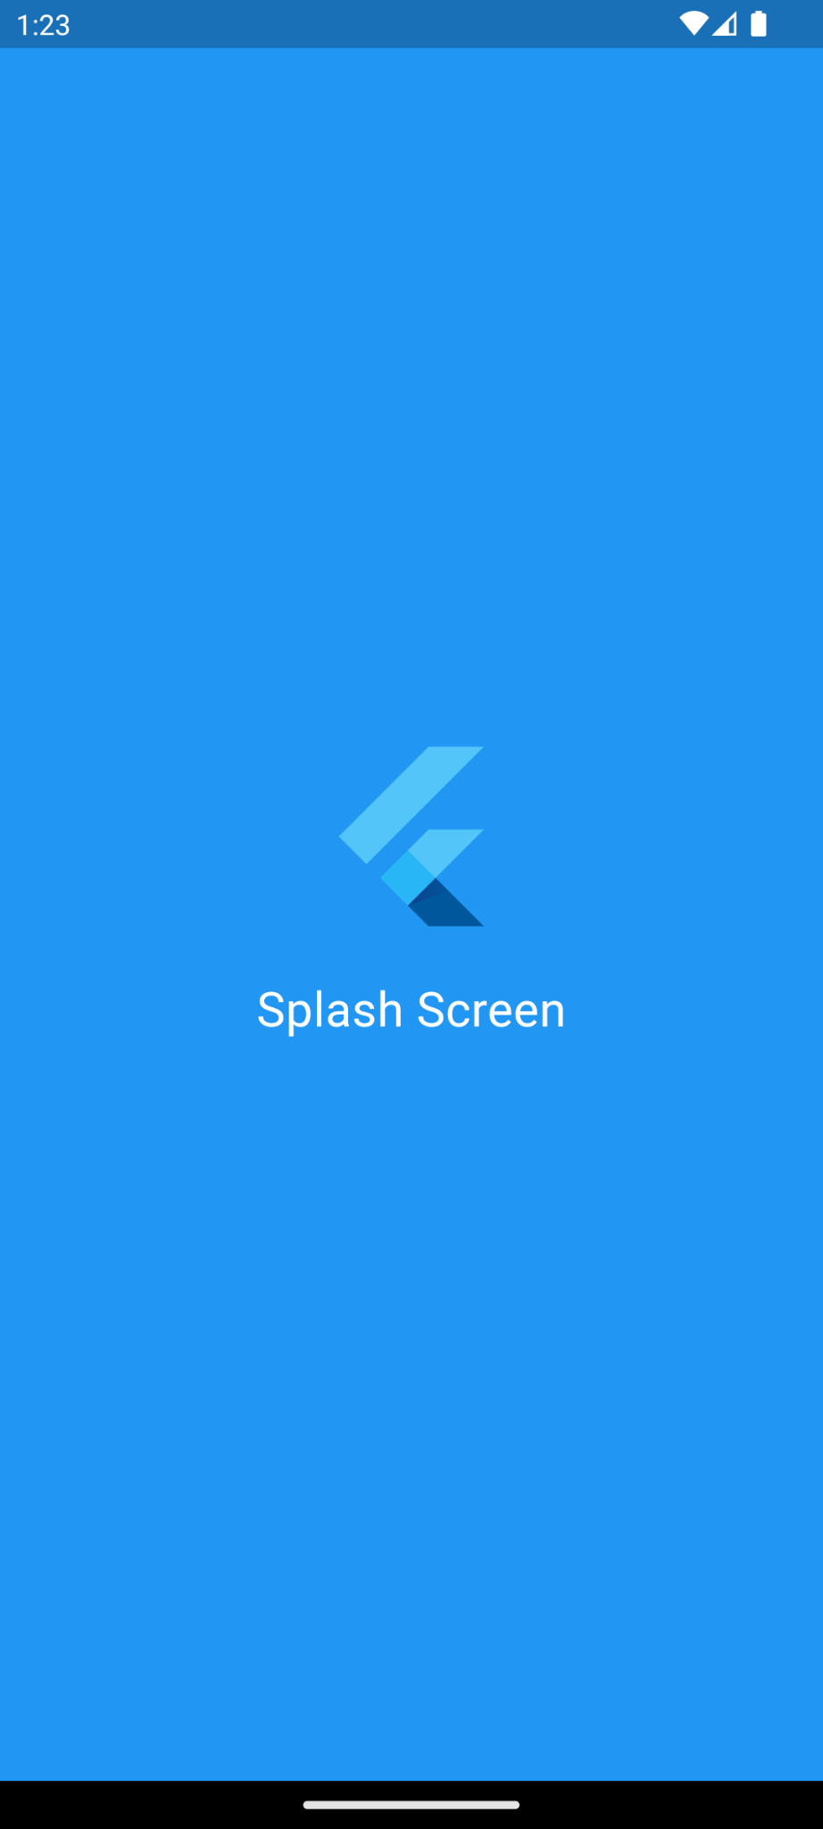 

# **How to submit your workshop**

Push your project back to the same git branch using command:

<command name>

# **Happy Coding!**